 

**Placement Empowerment Program**

***Cloud Computing and DevOps Centre***

Host a Static Website on a Cloud VM Install Apache on your cloud VM and host a simple HTML website.

Name: Mathimalar.P Department : ADS



**Introduction and Overview**

Setting up a virtual machine (VM) in the cloud allows you to create an isolated environment for running applications, testing, or developing software without the need for physical hardware. Using AWS's free-tier service, you can deploy a VM (known as an EC2 instance) to access and configure a cloud-based environment. SSH (Secure Shell) access enables you to securely connect to and manage this virtual machine remotely..

**Objective**

The objective of this task is to create and configure a free-tier AWS account, launch a virtual machine (EC2 instance), and securely connect to it using SSH. This includes:

* Setting up an AWS account and accessing the AWS Management Console
* Launching an EC2 instance with a free-tier eligible AMI (Amazon Machine Image)
* Configuring security groups to allow SSH access
* Generating and using an SSH key pair for secure authentication
* Connecting to the virtual machine via SSH to manage and interact with it

By completing this process, users will have a cloud-based virtual machine ready for development, testing, or deployment.

Importance

Setting up a cloud-based virtual machine offers several advantages:

* **Cost-Effective** – AWS offers a free-tier service for newcomers, allowing users to try cloud computing without incurring costs.
* **Scalability** – Virtual machines in the cloud can easily scale up or down based on usage requirements.
* **Remote Access** – SSH enables you to securely connect to and manage the virtual machine from anywhere.
* **Testing and Development** – Cloud VMs are ideal for testing, deploying, and developing applications in a controlled, isolated environment.
* **Learning and Experimentation** – This process provides an opportunity to learn and experiment with cloud-based infrastructure.

**Step-by-Step Overview**

**Step 1**

Have an HTML file (with any related assets like CSS/JavaScript) that you want to host in your GitHub repository

**Step 2** Launch an EC2 instance, select Ubuntu as the OS, configure security groups to allow all network traffic, create a key pair (e.g., new.pem), and download it for SSH access

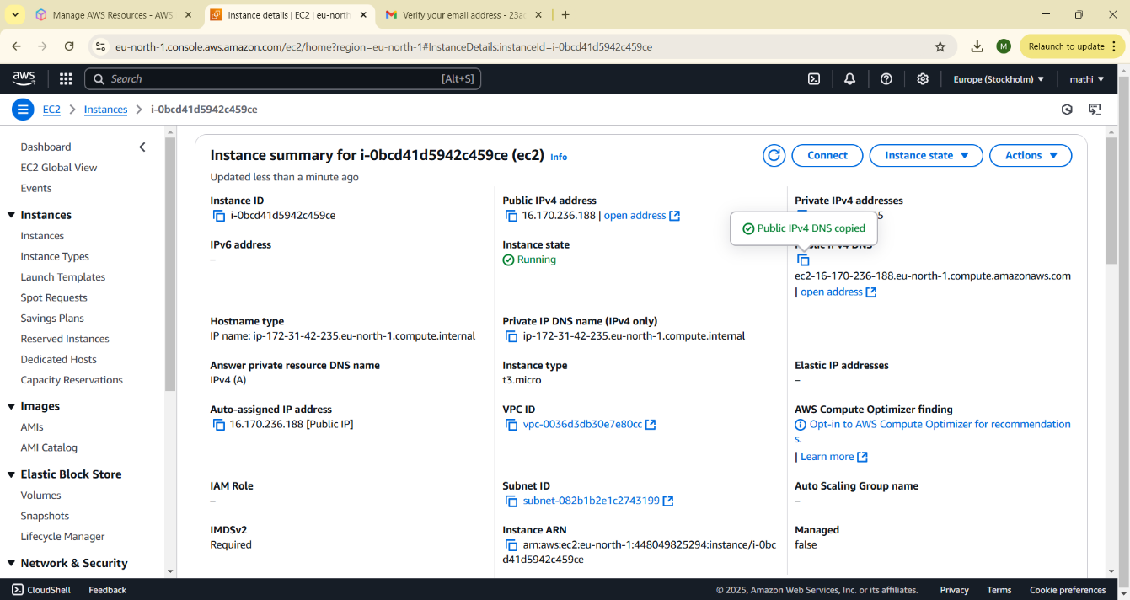

**Step3** Click the 'Connect' option on your launched instance, go to the SSH client section, and copy the command provided under the 'Example' section**.**

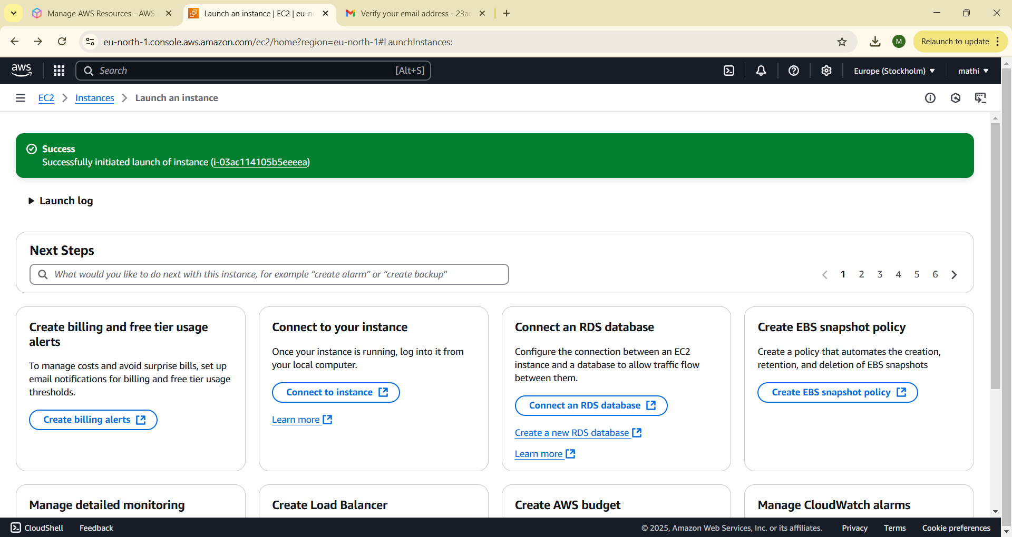

**Step 4:** :

Open PowerShell, navigate to the 'Downloads' directory where the downloaded key pair is located using the cd Downloads command

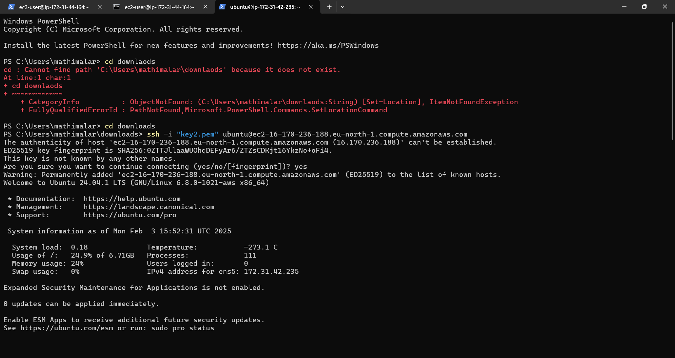

**Step 5:**

Paste the command copied from the EC2 Connect's SSH client section, replace the key pair name with your downloaded key (e.g., new.pem), press Enter, and type 'yes' when prompted.



**Step 6**

Run the command sudo apt update to update the package list

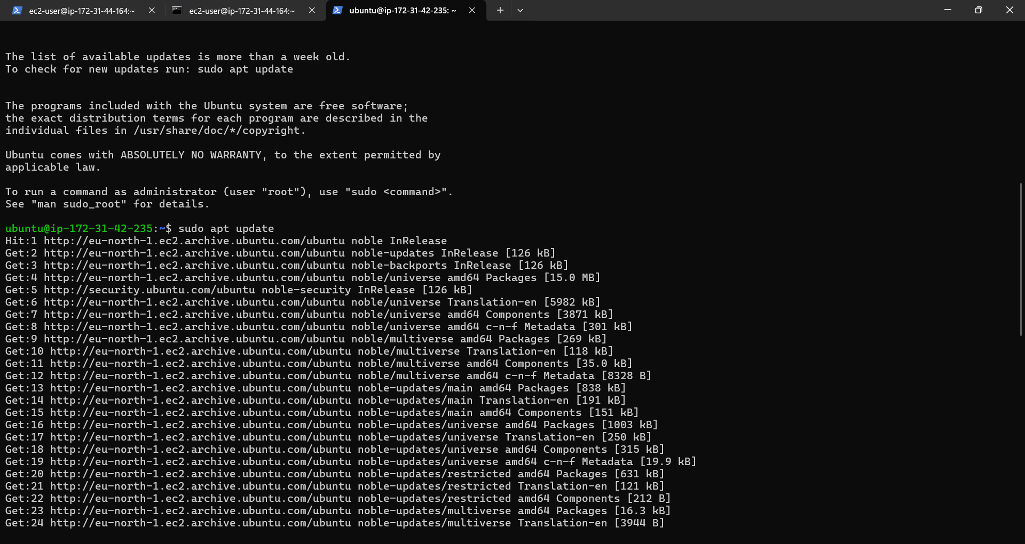

**Step 7:** Run the command sudo apt upgrade, and press 'Y' to confirm and continue the upgrade process

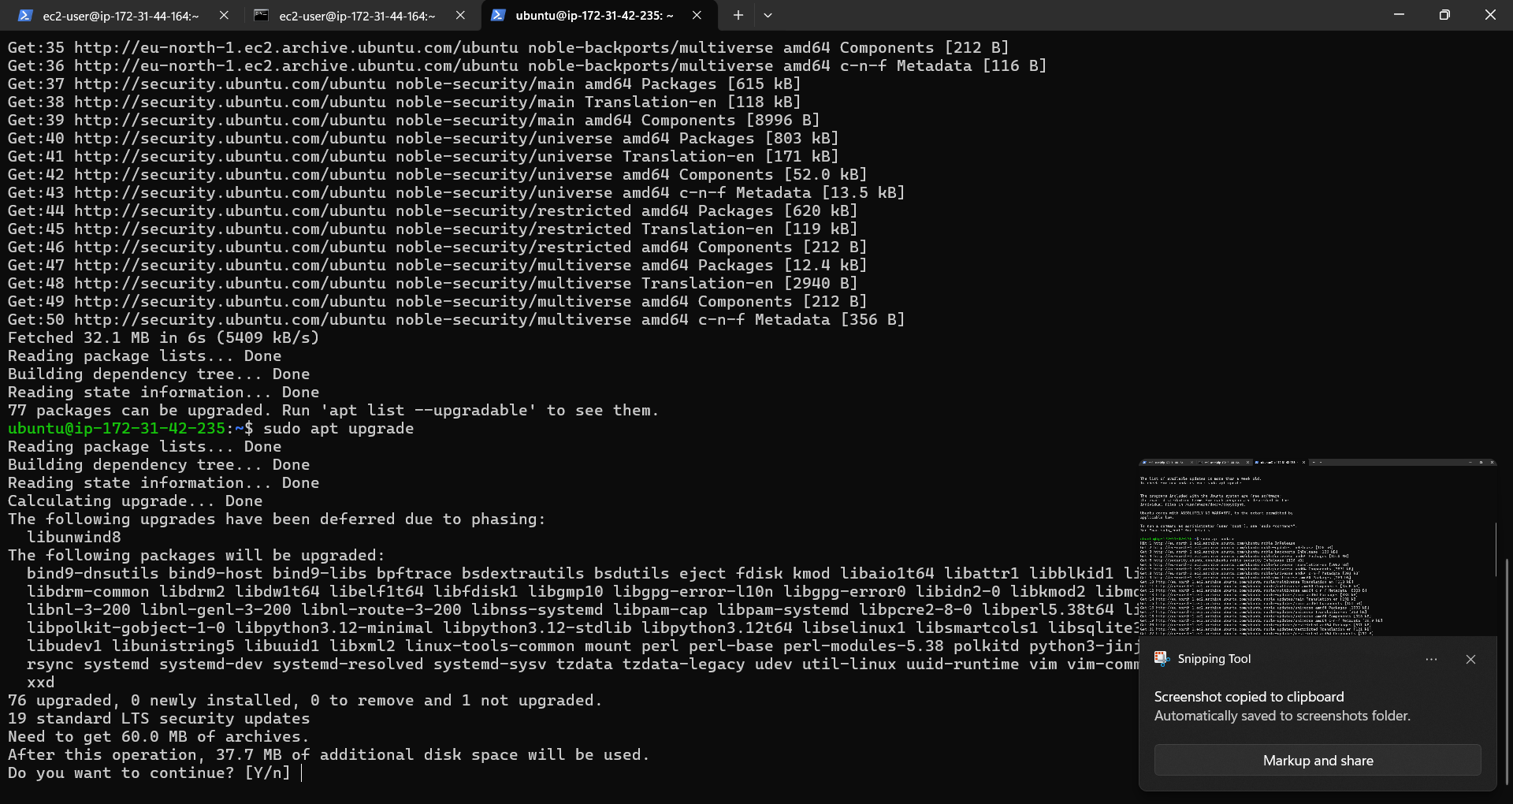

**Step 8:**

Install the Apache server by running the command sudo apt install apache2, and press 'Y' to confirm the installation

**Step 9:**

Insert your files by running the command git clone to clone your repository containing the website files

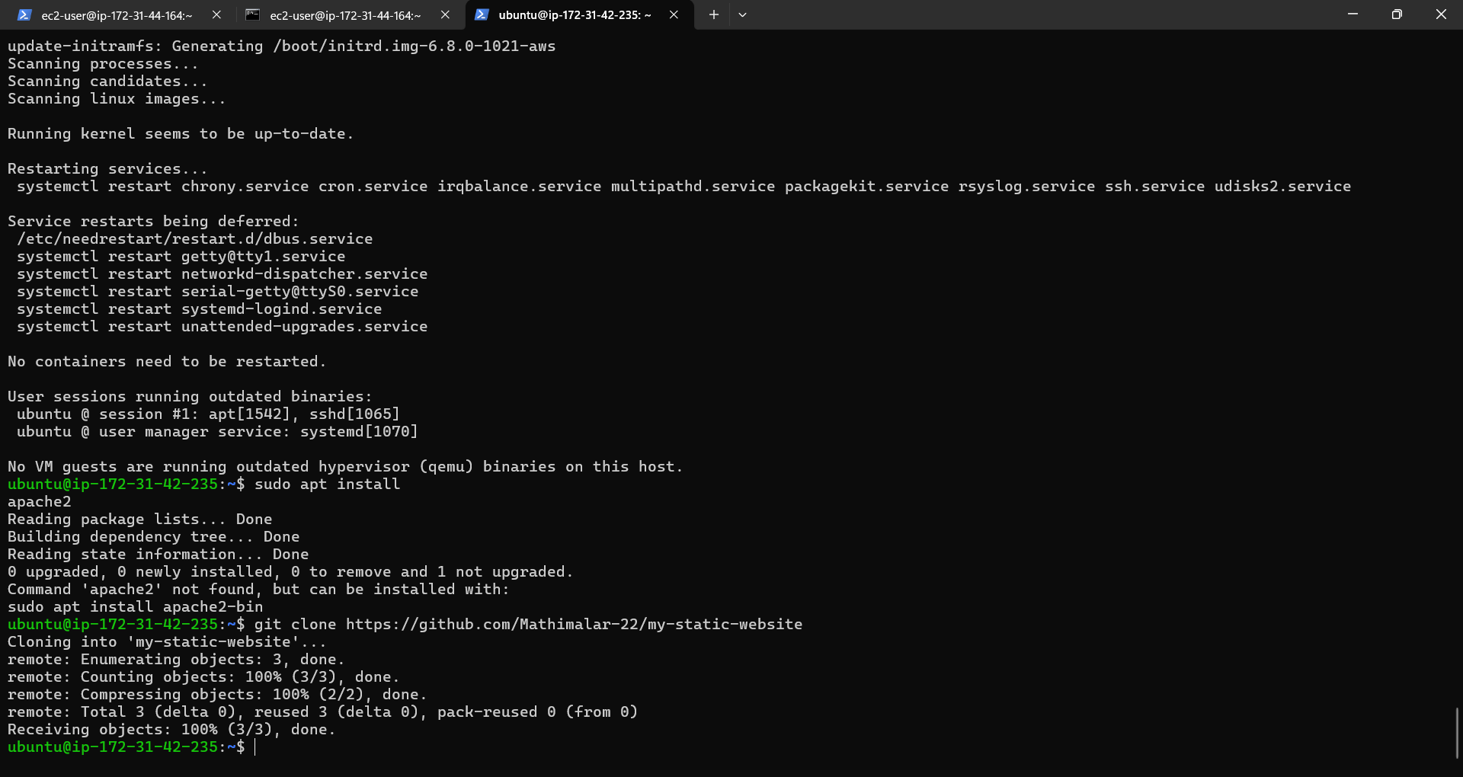

**Step 10:**

Run the command cd /var/www/html to navigate to the web server's root directory, then type ls to verify that your HTML files from the GitHub repository are present.

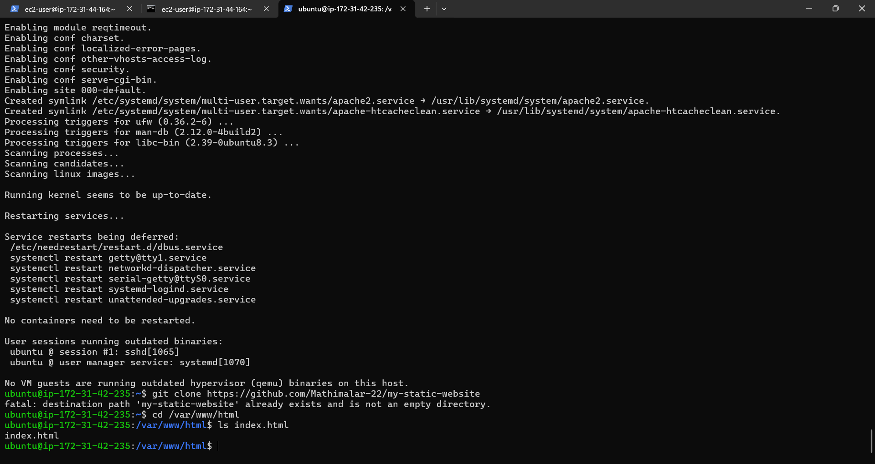

**Step 11:**

Copy the Public IPv4 DNS from the instance details page in the EC2 console, as shown in the image below.

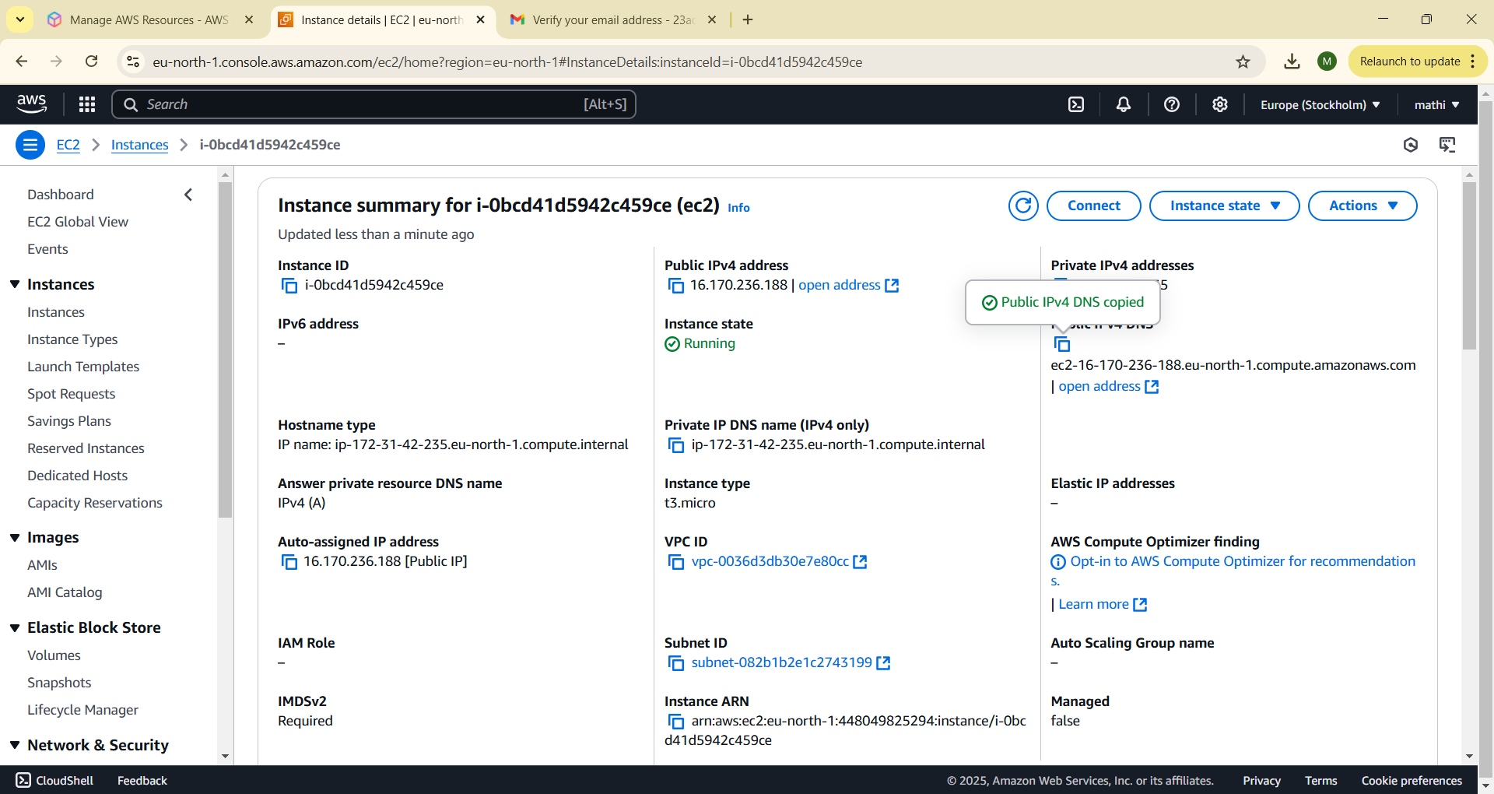

**Step 12:**

Open Chrome and paste the copied Public IPv4 DNS in the address bar to view the content of your index.html file.

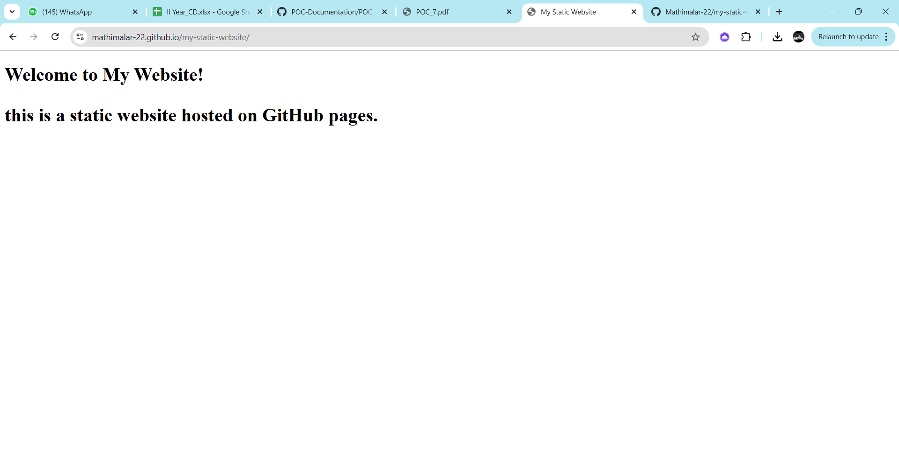

**Expected Outcome**

* The successful setup of a cloud-based VM will result in:
* A fully functional EC2 instance running on AWS, accessible through SSH
* The ability to perform tasks such as deploying applications, managing services, or testing configurations remotely
* Hands-on experience with cloud infrastructure and remote system management